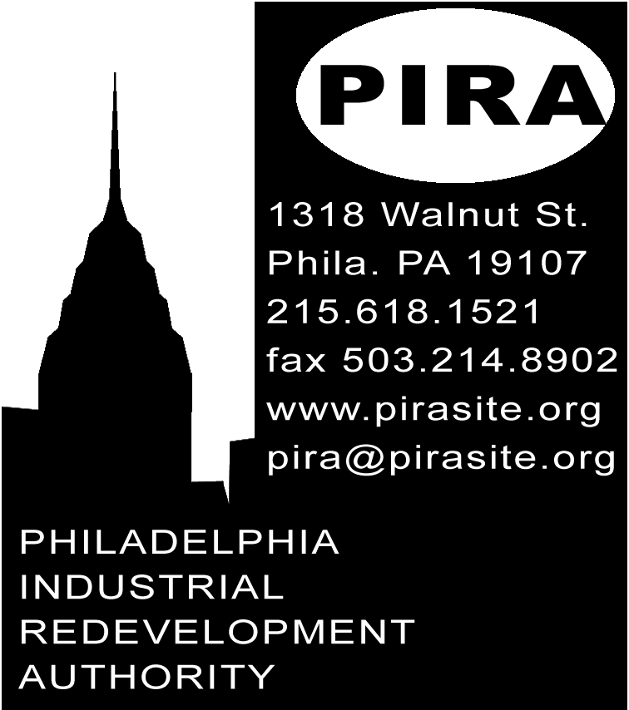
PRESS RELEASE

FOR IMMEDIATE RELEASE: JULY 19, 2002
CONTACT: MARK RIFKIN 215-618-1521 pira@pirasite.org

Philadelphia Industrial Redevelopment Authority kicks off “Save The DisneyHole” campaign
for disputed 8th and Market site
Entries to be displayed on-site 8/22 as alternative to parking lot

The search for alternatives to the City’s plan to turn the big muddy “DisneyHole” at 8th and Market back into a parking lot has entered a new phase with the Philadelphia Industrial Redevelopment Authority’s announcement of the “Save The DisneyHole” campaign and “The Great DisneyHole Exposition.”

“Since the spectacular failure of the Ken Goldenberger’s Eighth and Market DisneyQuest project, Philadelphia has been left with a muddy pit with no surrounding sidewalks. The “DisneyHole”, as it is called by many Philadelphians, sits empty and surrounded by a chain-link fence,” explains Joe Smith, PIRA Project Analysis Coordinator. “The City had an agreement to buy the lot from Goldenberger if the development failed, and now plans to turn the property back into a parking lot in an effort to recoup some of the tens-of-millions of dollars it lost on the project. PIRA has a better idea.”

PIRA Director of Project Planning Mark Rifkin elaborates, “The Exposition is a general call for any and everyone, whatever their background and training, to submit their ideas for creative uses for Philadelphia’s DisneyHole.”

All entries will be displayed on-site at the Exposition’s August 22nd premier at the DisneyHole itself. At the end of the showing, all entrants will be encouraged to take their proposals to Reset Art, at 201 S Camac St. for installation and an opening party. PIRA will provide basic materials for the creation of last-minute entries throughout the evening, and wall space will be available during the opening party and throughout the month of the show for any late proposals.

Several promising alternative uses have already been put forward for the Hole, including the “Museum of Corporate Welfare” proposal by Philadelphia artist Albo Jeavons, and the proposals included in the article “9 Dreams For 8th & Market” in the March 31st issue of the Inquirer Magazine.

“Everyone is encouraged to submit an idea for the Hole. No special training, degree, certification, or technical expertise is required. We will accept submissions of any kind. If you want to submit a drawing, anything from a rough sketch to an architectural rendering is fine. Don't like to draw? We will accept submissions in any medium: a model, a written or recorded description, a poem or song, a performance... Any and all ideas, from thepractical to the visionary will be considered. PIRA's aim is to stimulate discussion and debate. The city needs your inspiration, so follow your interests and passions and submit your proposals,” invites PIRA’s Rifkin.

PIRA, a quasi-private not-for-profit organization, uses grassroots democratic planning as a means to address the root causes of urban problems, bringing ordinary citizens into the heart of the planning process. Downloadable entry materials and a list of pick-up locations for materials will be available online at http://www.pirasite.org

- 30 -

